



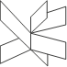

**IT-DWHY-S18 course project**

144036 Cristian Russu

254272 Sara Nunes

231735 Nadina Allison

Supervisor: Bo Brunsgaard Christensen

VIA, ICT

Horsens, 2018

Table of content:

1.Dimensional data model, UML 3

2. DDL - se attached files 3

3. A source-to-target mapping - se attachment. 3

4. Code for populating a static dimension-se attachment 3

5. & 6. ETL - se attached files 3

7. Documented tests of the flows.3

### 1.Dimensional data model, UML

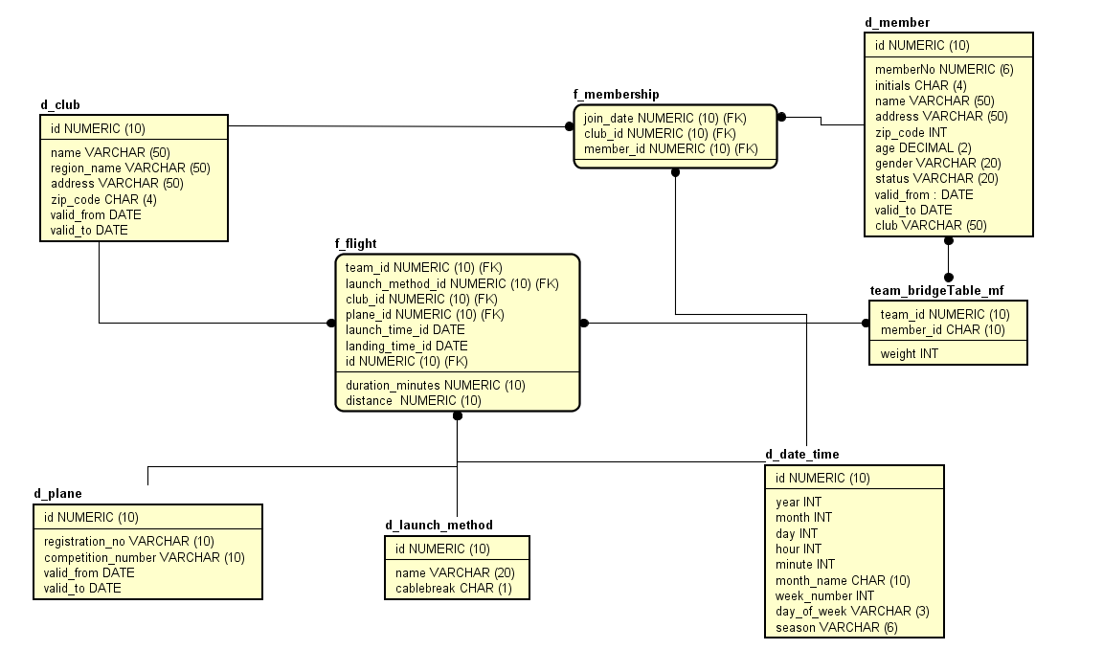

### 2. DDL - se attached files

### 3. A source-to-target mapping - se attachment.

### 4. Code for populating a static dimension-se attachment

### 5. & 6. ETL - se attached files

### 

### 7. Documented tests of the flows.

Test of the dimension member.

Updates and inserts on DWH member table:

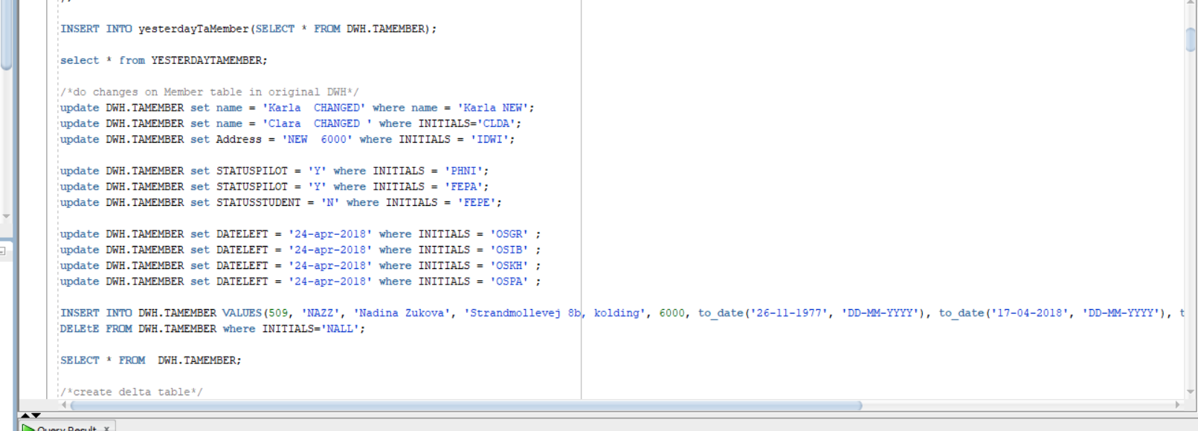

DeltaMembertable:

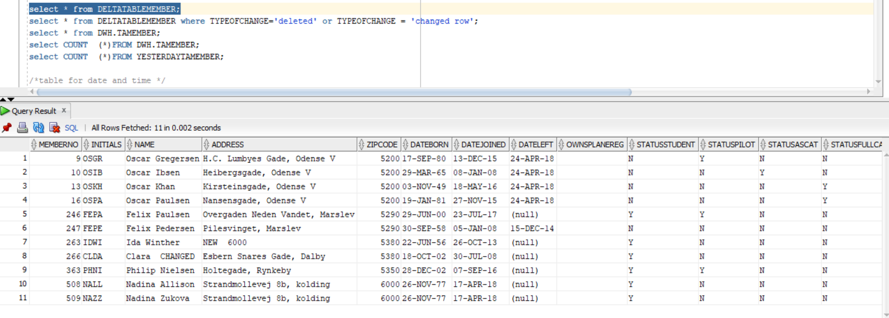

Validated members:

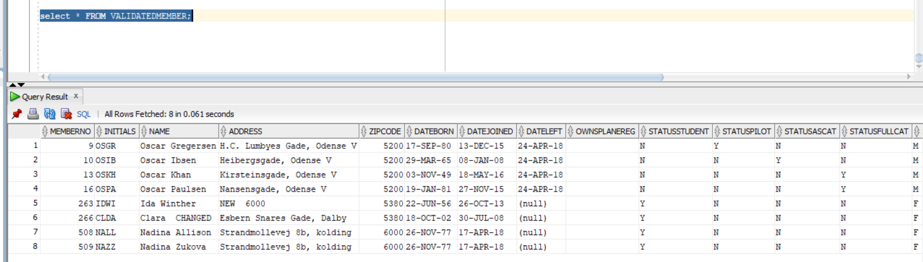

Removed entries:

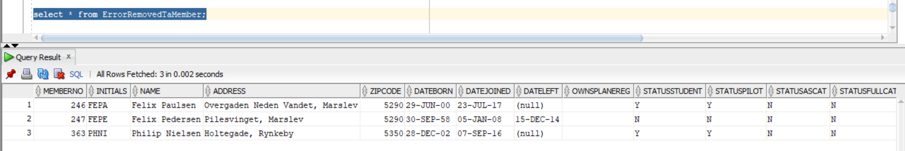

Transformed member:

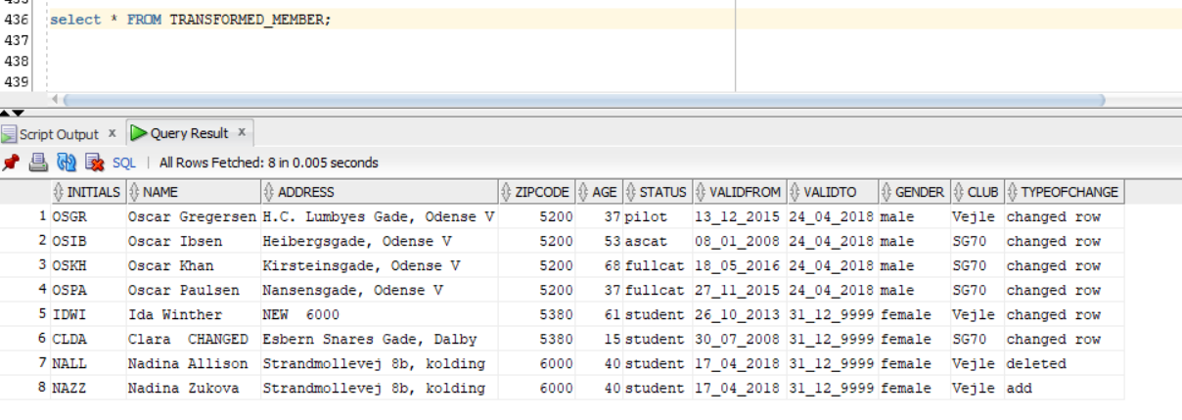

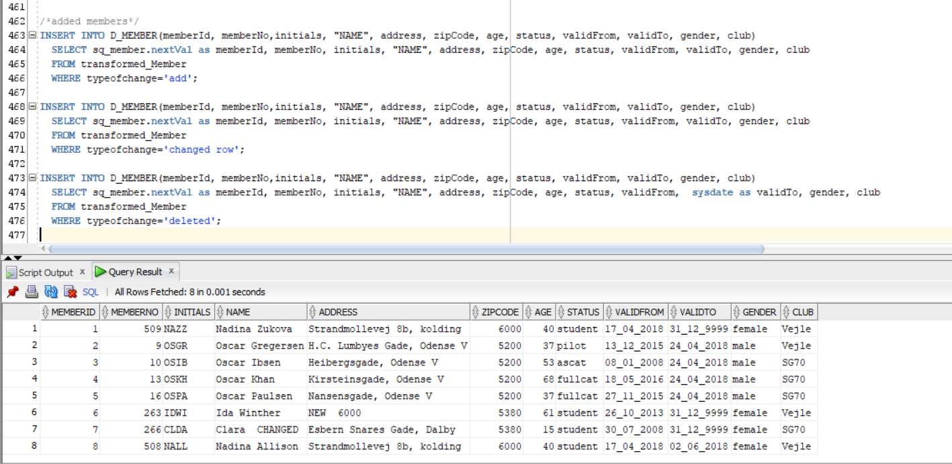

2. Test of the fact table

First we **inserted 2 new flights**, one with **one pilot**, and the second one with **2 pilots** in the taFlightsVejle.

Inserting one pilot

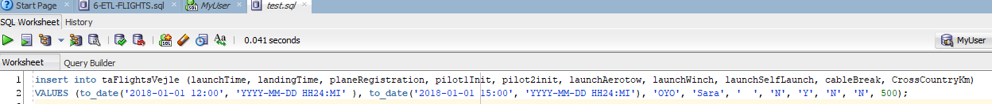



Inserting two pilots





Our f_flight table looked like this in the end, and the id’s matched with the ones we inserted.

